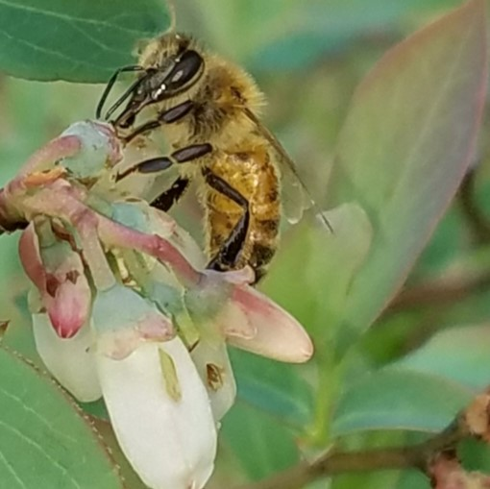

2023 Bee Prices

Contact for availability. Pick up in Bonaire or Hiawassee.
Nucs $175
Queen cells $6
Virgin Queens $12
Instrumental Inseminated Queens $250

